* **Pick up manager view: -**
* Pick up manager view module is only visible to pick up manager and super admin.
* Click on Credit Card
* Click on Pick up Manager View

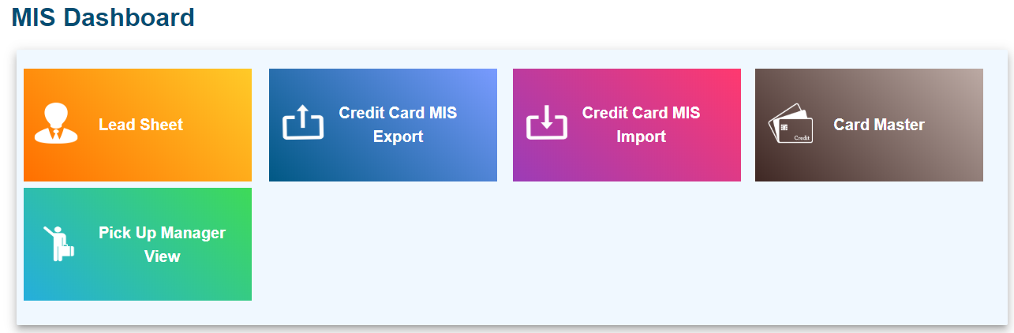

1. **Lead Sheet View : -**

* Credit card Leads whose document collection is pending i.e. pickup status is pending, which are displayed in lead sheet view table.
* User is able to search records by selecting from date and to date and click on search.

1. **Mis View : -**

* CC Leads whose document collection is completed i.e. pickup status is completed, which are displayed in Mis view table.
* User is able to search records by selecting from date and to date and click on search.

1. **PL Pending: -**

* Personal loan leads whose document collection is pending i.e. pickup status is pending are displayed in this table.
* User is able to search records by date and location wise follow below steps
* Choose date from
* Choose date to
* Select location
* Click on search
* User is able to download PL pending report
* **Export:** User is able to download PL pick up report follow below steps: -
* Click on Export Report
* Click on Export
* Click on OK
* You will get the sheet like below

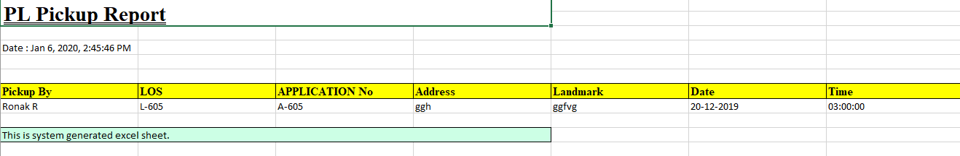

1. **PL Completed: -**

* Personal loan leads whose document collection is completed i.e. pickup status is completed are displayed in this table.
* User is able to search records by date and location wise follow below steps
* Choose date from
* Choose date to
* Select location
* Click on search
* **Export:** User is able to download PL pick up report follow below steps: -
* Click on Export Report
* Click on Export
* Click on OK
* You will get the sheet like below sheet.

